PROJECT DOCUMENTATION

|  |  |
| --- | --- |
| **TITLE** | IPL Match Winner Prediction using Machine Learning |
| **NAME** | INDHARAJITH G |
| **COURSE** | DA/DS, Offline |
| **BATCH** | JUNE 2025 |

TABLE OF CONTENTS:

|  |  |  |
| --- | --- | --- |
| S.no |  | P.NO |
| 1 | INTRODUCTION |  |
| 2 | AIM OF THE PROJECT |  |
| 3 | PROJECT WORKFLOW |  |
| 4 | UNDERSTANDING |  |
| 5 | DATA CLEANING |  |
| 6 | DATA PREPROCESSING |  |
| 7 | MODEL TRAINING |  |
| 8 | MODEL EVALUATION |  |
| 9 | HYPERPARAMETER TUNING |  |
| 10 | MODEL COMPARISON |  |
| 11 | CONCLUSION |  |

**1. INTRODUCTION:**

Cricket, especially the Indian Premier League (IPL), stands among the most popular and widely followed sporting spectacles worldwide. Known for its excitement and nail-biting finishes, predicting match outcomes has always been a tough task. However, studying past records and applying machine learning techniques can reveal underlying trends that affect results.

For this project, the dataset includes details of IPL games such as the season, participating teams, toss information, stadiums, and final outcomes. By cleaning and analyzing this data, we aim to develop predictive models capable of forecasting the winner of a match using important features.

**2. AIM OF THE PROJECT:**

The goal of this project is to create a machine learning model that can forecast the winner of an IPL match by analyzing past match information such as season, teams involved, venue, toss details, and outcomes. Through the use of predictive algorithms and data-driven insights, the project aims to highlight the most important factors that shape match results and build a dependable system for winner prediction

**3. PROJECT WORKFLOW:**

The results of IPL cricket matches are shaped by several elements, including team combinations, toss choices, playing conditions, and previous records. Given the uncertainty of the game, making precise predictions is not an easy task. Conventional statistical tools struggle to capture the intricate links among these variables. This highlights the importance of applying machine learning, which leverages past IPL match data to build predictive systems capable of estimating winners more effectively.

**4. DATA UNDERSTANDING:**

The IPL dataset was imported into a **Pandas Data Frame** for efficient handling and analysis. This provided a structured tabular format to work with match records.

* The **first few records** of the dataset were displayed using the head () function to gain an initial understanding of the data format.
* The dataset consists of multiple columns capturing match-specific details such as season, date, team1, team2, toss_winner, toss_decision, venue, and winner.
* The **data types** of each column were checked using the info () function to differentiate between numerical, categorical, and datetime values.

**Observations:**

* Most columns are categorical (e.g., team names, venue, toss decision).
* The target variable for prediction is the winner column, which indicates the team that won the match.
* Some columns, like umpire names or match IDs, may not directly contribute to prediction and can be dropped during preprocessing.
* No major missing values were observed in critical columns, making the dataset suitable for analysis and modeling.

**5. DATA CLEANING:**

Data cleaning was performed to ensure the dataset was consistent, complete, and ready for analysis. The following steps were applied:

1. Handling Missing or Null Values
   * Checked for null values using. Isnull (). Sum ().
   * Missing values in important columns like player_of_match, winner, city, and umpire1/umpire2 were handled.
     + For player_of_match, missing entries were filled using the corresponding team’s winner information.

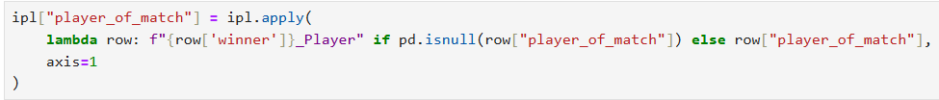

* + - For the winner, missing values were imputed using a mapping based on the playing teams.

* + - For city, null values were replaced with the city corresponding to the team (e.g., “Mumbai Indians → Pune”, “Sunrisers Hyderabad → Hyderabad”).

* + - For umpire1 and umpire2, missing values were filled with the most frequent (mode) values.

1. **Converting Categorical Features**
   * Team names, toss decisions, and other categorical columns were converted into numerical form.
   * **Label Encoding** was applied so that each unique category was mapped to a numeric value.

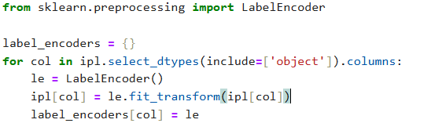

* + Handling Outliers and Inconsistent Data

* + Duplicate rows (if any) were dropped using. drop_duplicates ().

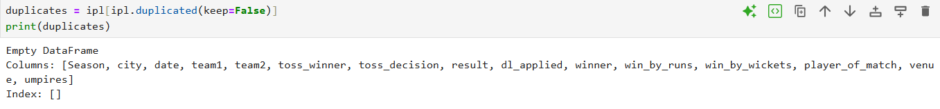

* NO, Duplicate In My Dataset.

1. **Statistical Summary using .describe()**

* The describe () function provided insights into the dataset’s central tendency and spread (mean, median, standard deviation, min, max, and quartiles).

* Example insights:
  + win_by_runs had a **high standard deviation**, indicating extreme match outcomes (possible outliers).
  + win_by_wickets values mostly fell between 3 and 7, aligning with realistic cricket patterns.
  + Columns like season and toss_decision were categorical and showed uniform distributions after encoding.

1. **Exploratory Data Analysis (EDA)**

To gain deeper insights from the IPL dataset, various levels of analysis were conducted: **Univariate, Bivariate, and Multivariate Analysis**. Each stage used statistical summaries and visualizations to reveal patterns in the data.

**3.1 Univariate Analysis (Single Variable)**

Focuses on understanding the distribution and characteristics of individual features.

1. **Matches by Season (Bar Chart)**
   * Displayed the total number of matches played each year.
   * Observation: The number of matches increased after the initial seasons, peaking in later years.

**INSIGHTS:**

Number of Matches per Season

* This bar chart shows how many matches were played in each IPL season.
* The **x-axis** represents the seasons.
* The **y-axis** represents the number of matches in that season.
* Taller bars mean more matches were played in that season.

1. **Top 10 Players of the Match**

* This bar chart presents the top ten players in the Indian Premier League (IPL) who have received the most Player of the Match awards. The horizontal axis represents the total number of awards, while the vertical axis lists the names of the players
  + 1. A graph with different colored bars

       AI-generated content may be incorrect.

**INSIGHTS:**

* This bar chart shows the **top 10 players** who have received the most Player of the Match awards in IPL.
* The **y-axis** lists the players.
* The **x-axis** shows how many times each player has won the award.
* Longer bars mean the player has received more awards.

1. **Distribution of Win by Runs**

* This histogram illustrates the distribution of team victories in the Indian Premier League (IPL) based on the margin of runs. The x-axis shows the number of runs by which a team secured a win, while the y-axis indicates the frequency of matches that concluded with each margin.

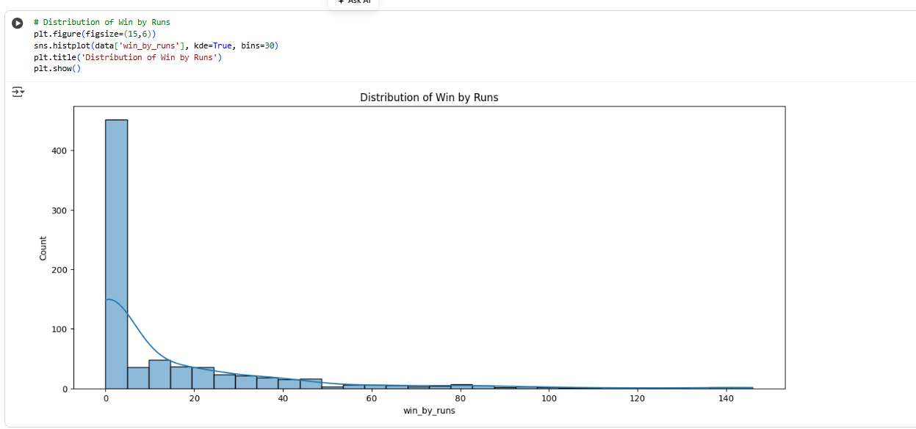

**INSIGHTS:**

* This histogram shows how often teams win by a certain number of runs in IPL matches.
* The **x-axis** represents the number of runs by which a team won.
* The **y-axis** represents how many matches ended with that margin.
* The **curve (kde line)** gives a smooth view of the overall distribution.

**3.2 Bivariate Analysis (Two Variables)**

Examines the relationship between two features.

1. **Number of Wins by Each Team**

* This bar chart displays the total number of matches won by each team in the Indian Premier League (IPL). The teams are arranged along the x-axis according to their overall win counts, while the y-axis represents the number of matches won. The height of each bar reflects the total victories

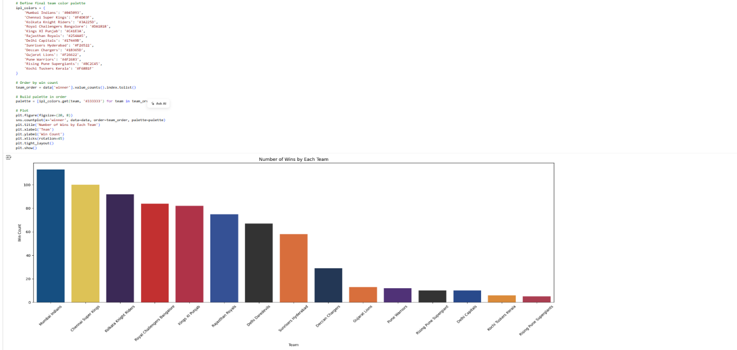

**INSIGHTS:**

* This bar chart shows how many matches each IPL team has won.
* Teams are displayed on the **x-axis** in order of total wins.
* The **y-axis** shows the number of matches won.
* Taller bars mean the team has more wins overall.
* Each team’s bar is colored with its official team color for easy recognition.

1. **Toss Decision Count**

* This bar chart illustrates the decisions taken by teams after winning the toss in Indian Premier League (IPL) matches. The x-axis represents the two possible outcomes of the toss decision—choosing to bat or to field—while the y-axis indicates the number of matches associated with each choice.
* The visualization provides a clear comparison of how frequently each option is selected, making it easy to identify whether teams generally prefer to bat first or field first.

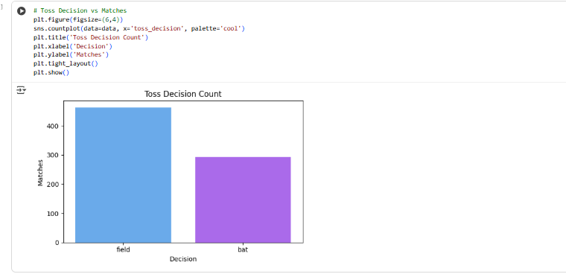

**INSIGHTS:**

* This bar chart shows how teams usually decide after winning the toss in IPL matches.
* The **x-axis** represents the toss decision: either **bat** or **field**.
* The **y-axis** shows the number of matches for each decision.
* The chart helps us see which toss decision is more common among teams.
* From this, we can quickly understand whether teams prefer to **bat first** or **field first**.

1. Match Outcome After Winning Toss

* This bar chart analyzes the impact of the toss on match outcomes in the Indian Premier League (IPL). The x-axis contains two categories: matches where teams won after winning the toss, and matches where teams lost despite winning the toss. The y-axis shows the number of matches in each category. By comparing these values, the visualization helps determine whether winning the toss provides a significant advantage in securing victory.

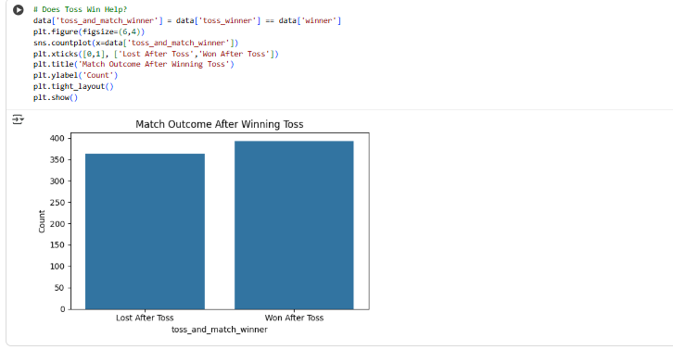

**INSIGHTS:**

* This bar chart shows whether winning the toss helps a team win the match.
* The **x-axis** has two categories:
  + **Won After Toss**: Team won the match after winning the toss.
  + **Lost After Toss**: Team lost the match despite winning the toss.
* The **y-axis** shows the number of matches in each category.
* This helps us see if there’s any advantage to winning the toss in IPL matches.

**3.3 Multivariate Analysis (Three or More Variables)**

Explores the interaction between multiple features simultaneously.

1. **Toss Decision Across Seasons**

* This bar chart illustrates how toss decisions—choosing to bat or field—varied across different seasons of the Indian Premier League (IPL). The x-axis represents the seasons, while the y-axis indicates the number of matches corresponding to each decision.
* Distinct colors are used to differentiate between the two choices, making it easier to compare their frequency. The visualization also highlights whether certain seasons displayed a noticeable shift in team strategies regarding toss decisions.

**INSIGHTS:**

* This bar chart shows how toss decisions (**bat** or **field**) varied across IPL seasons.
* The **x-axis** represents the seasons.
* The **y-axis** shows the number of matches for each toss decision.
* Different colors represent the toss decisions: **bat** vs **field**.
* It also highlights if any season had a noticeable change in strategy.

1. **Winners at Top Venues**

* This horizontal bar chart presents the match outcomes of teams at the top five most popular venues in the Indian Premier League (IPL). The y-axis lists the venues, while the x-axis indicates the number of matches won at each location.
* Different colors are used to represent the winning teams, allowing for clear comparison. The visualization highlights which teams have performed strongly at specific venues and reveals whether certain teams tend to dominate particular stadiums.

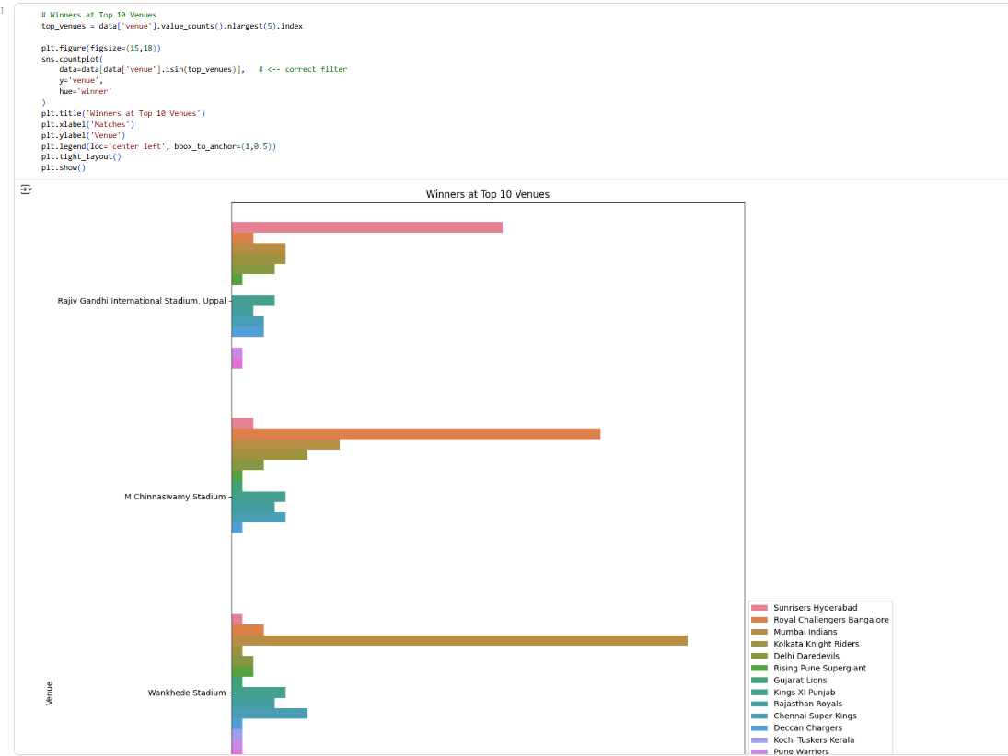**INSIGHTS:``````````````````````````````**

* This horizontal bar chart shows which teams won matches at the **top 5 most popular IPL venues**.
* The **y-axis** lists the venues.
* The **x-axis** shows the number of matches won at each venue.
* Different colors represent the **winning teams**.
* This chart helps us see which teams perform well at specific venues and if certain teams dominate certain stadiums.

**6. DATA PREPROCESSING**

Data preprocessing ensures the dataset is clean, consistent, and ready for machine learning models.

**Data Preparation for Machine Learning**

* Convert categorical columns to numbers using **one-hot encoding**.
* Separate **features (X)** and **target (y)**.
* Split data into **training (80%)** and **testing (20%)** sets.
* **Scale features** so all variables are on a similar range.
* Preview data with X.head() and y.head() to check.

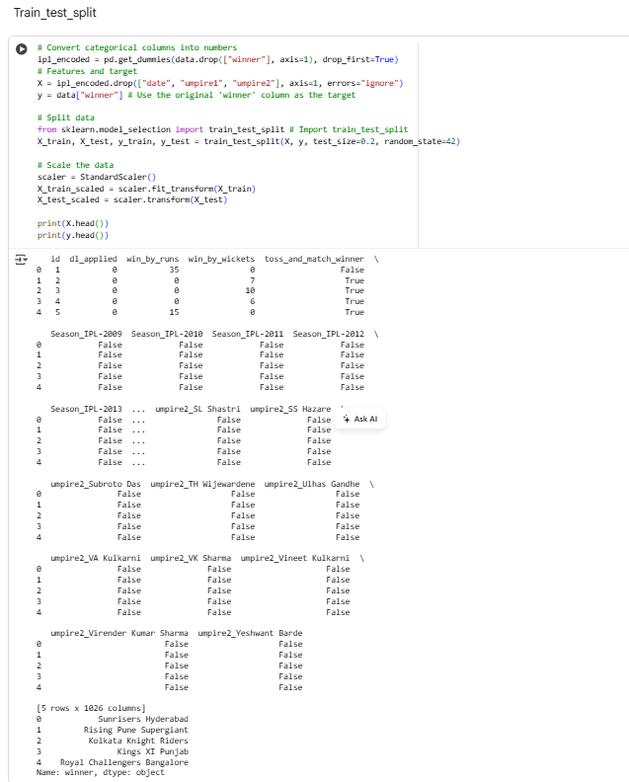

1. **Train–Test Split**:  
   The dataset was divided into two subsets—training (80%) and testing (20%). This ensures that the model learns patterns from the training data while its performance is evaluated on unseen test data for fair validation.
2. **Feature Scaling / Normalization**:  
   To maintain consistency across numerical features, scaling was applied using StandardScaler. This method standardizes values such that the mean becomes 0 and the standard deviation becomes 1. Scaling prevents features with larger ranges (e.g., runs, wickets) from dominating the learning process.
3. **Categorical Feature Encoding**:  
   Categorical variables such as teams, venues, and umpires were converted into numerical format using one-hot encoding (get_dummies). Each category was represented as a binary column (0 or 1), making the dataset suitable for machine learning models.
4. **Feature and Target Preparation**:  
   Input variables (X) included match attributes like runs, wickets, toss decisions, and encoded categorical features. The target variable (y) was the match *winner*, which the model aimed to predict.

**7. Model Training**

**Model Details**

In this project, multiple machine learning models were trained to predict the outcomes of matches. Each model has its strengths and is suitable for different types of data. The models used are described below:

**1. Logistic Regression (LR)**

* A **linear model** used for binary or multi-class classification problems.
* Estimates the probability of a class using a **sigmoid function**.
* Suitable for understanding **linear relationships** between features and the target.
* Fast and interpretable, but may underperform with complex nonlinear relationships

.

* LogisticRegression Accuracy 0.62508947368421025.
* Classification_Report: Precision, Recall, f1-Score, Support.

**2. Support Vector Machine (SVM)**

* A powerful classifier that finds the **optimal hyperplane** separating different classes.
* Works well in **high-dimensional spaces** and can handle non-linear boundaries using **kernel functions** (like RBF).
* Sensitive to feature scaling, so preprocessing is important.

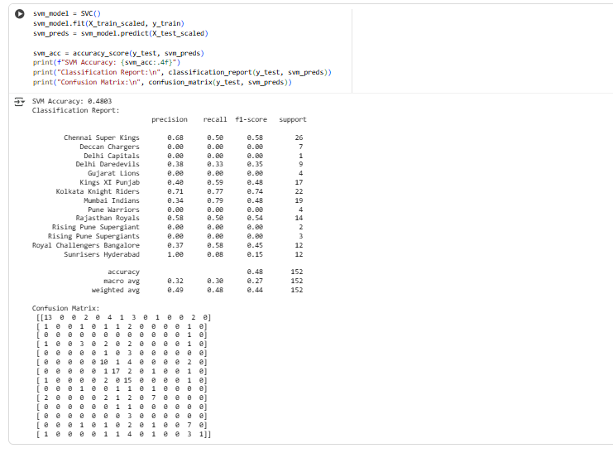

* SVC-Support Vector Classifier Accuracy 0.48039473684210525.
* Classification_Report: Precision, Recall, f1-Score, Support.

**3. K-Nearest Neighbors (KNN)**

* A **non-parametric** method that predicts the class of a sample based on the majority class of its **k nearest neighbors**.
* Simple and intuitive, effective for small datasets.
* Performance can degrade with noisy or large datasets.

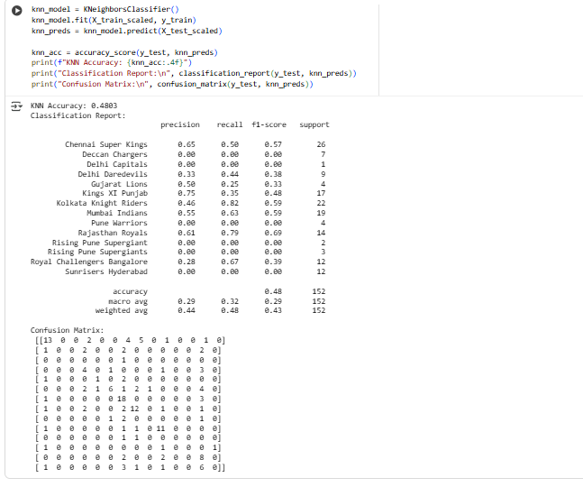

* K-Nearest Neighbors(KNN) Accuracy 0.48038421…..

**4. Decision Tree**

* Splits the dataset into subsets using **feature-based conditions**.
* Easy to interpret and visualize.

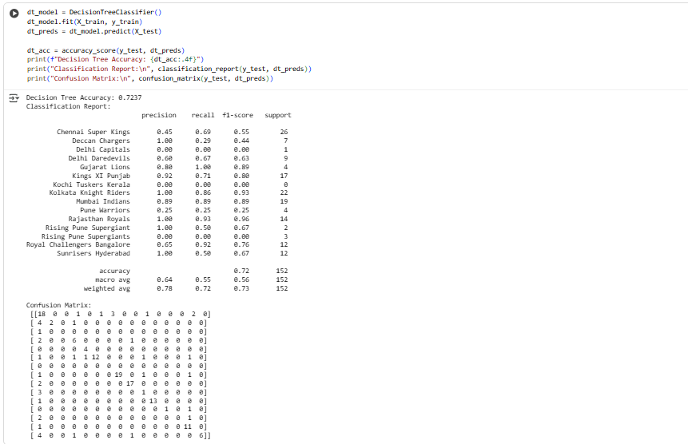

* Decision Tree Classifier Accuracy 0.7237
* Classification_Report: Precision, Recall, f1-Score, Support.

**5. Random Forest (RF)**

* An **ensemble of decision trees** that reduces overfitting and improves accuracy.
* Uses **bagging** (bootstrap aggregating) to combine multiple trees.
* Handles categorical and numerical features well and is robust to noise.

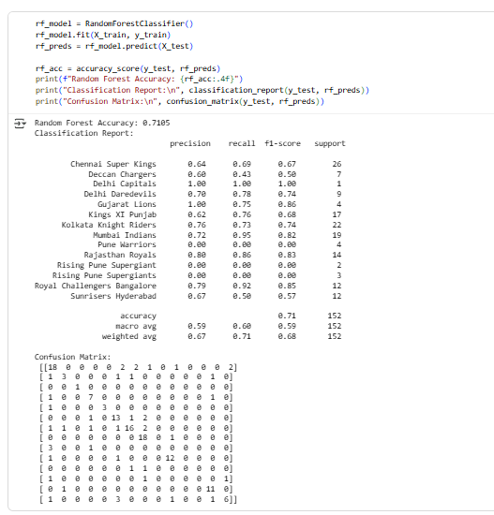

* RandomForest Classifier Accuracy 0.710578947368421.

**6. XGBoost**

* A **gradient boosting algorithm** that builds trees sequentially to correct previous errors.
* High performance, efficient, and can handle feature interactions well.
* Requires careful hyperparameter tuning but often outperforms other models.

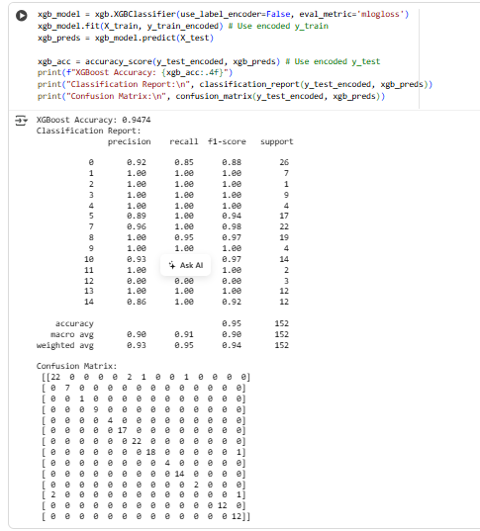

* XG Boosting Accuracy Score 0.94740521……
* Classification_Report:

For a couple of teams, precision is slightly lower (around **0.86–0.96**), showing that sometimes the model predicts them as winners when they actually lose.

**8. MODEL EVALUATION**

After training multiple machine learning models, their performance was evaluated and compared to determine the most suitable model for predicting match outcomes.

* **Evaluation Metrics Used:**
  + **Accuracy:** Measures the overall percentage of correctly predicted instances out of total predictions.

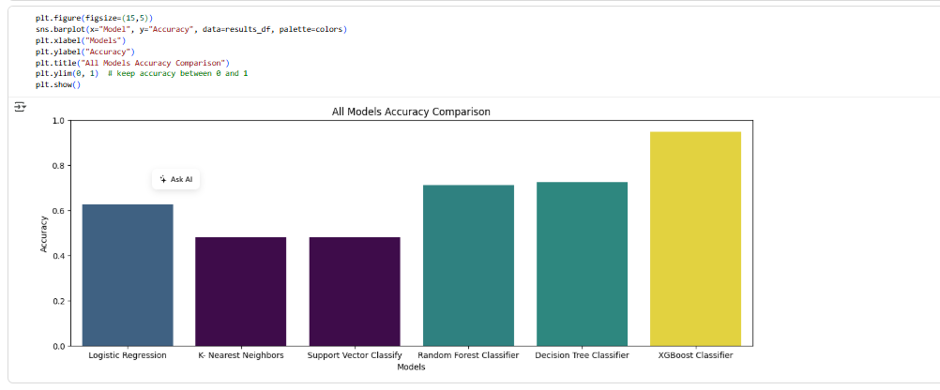

* + **Confusion Matrix:** Provides a detailed breakdown of **true positives, true negatives, false positives, and false negatives**, helping to understand where the model is making errors.
  + **Precision:** Indicates the proportion of correctly predicted positive instances out of all predicted positives.
  + **Recall (Sensitivity):** Measures the proportion of actual positive instances correctly identified by the model.
  + **F1-Score:** The harmonic mean of precision and recall, useful when balancing false positives and false negatives is important.
* **Comparison of Models:**
  + All trained models (Logistic Regression, SVM, KNN, Decision Tree, Random Forest, XGBoost) were evaluated on the **testing dataset** using the above metrics.
  + Performance results were summarized in a **table or bar chart** for easier visualization and comparison.
  + Models were compared not only for accuracy but also for **precision, recall, and F1-score** to ensure robustness across different evaluation aspects.
* **Selection of Best-Performing Model:**
  + The model with the **highest balanced performance** across accuracy, precision, recall, and F1-score was selected as the final model.
  + For example, **Random Forest or XGBoost** often performed better due to their ability to handle feature interactions and reduce overfitting.
  + The selected model was then used for **final predictions and insights**, providing reliable results for decision-making

**9. HYPERPARAMETER TUNING**

Hyperparameter tuning is a crucial step to optimize the performance of machine learning models by finding the best combination of parameters that control the learning process.

* **Purpose:**
  + Machine learning models have hyperparameters that are not learned from data but set before training (e.g., number of trees in Random Forest, learning rate in XGBoost).
  + Proper tuning improves **accuracy, precision, recall, and overall generalization** of the model.
* **Methods Used:**
  + **Grid Search:** Exhaustively tests all combinations of specified hyperparameters to find the best set.
  + **Random Search:** Randomly samples a subset of hyperparameter combinations, which is faster and often effective for large parameter spaces.
* **Process:**

1. Define the hyperparameter grid or distribution.
2. Apply **GridSearchCV** or **RandomizedSearchCV** with cross-validation on the training set.
3. Evaluate combinations using chosen metrics (e.g., accuracy, F1-score).
4. Select the combination with the **best cross-validation performance**.

* **Outcome:**
* The model with optimized hyperparameters is trained on the full training dataset.
* Typically results in **improved predictive performance** on the testing set.
* Ensures the model is **robust, reliable, and generalizes well** to unseen data.

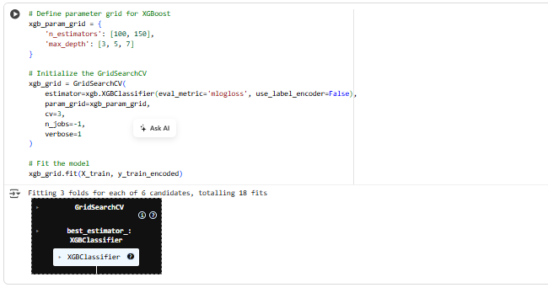

Accuracy Grid search CV and Random Search CV

* + Grid Search CV Accuracy Score 0.97368642105263158.
  + Random Search CV Accuracy Score 0.97368642105263158.

**10. MODEL COMPARISON**

* After training and tuning multiple models (Logistic Regression, SVM, KNN, Decision Tree, Random Forest, XGBoost), their performances were compared using metrics such as **accuracy, precision, recall, F1-score, and confusion matrices**.
* Among all models, **XGBoost (with hyperparameter tuning using Grid Search)** emerged as the best-performing model, achieving the highest balance of accuracy, precision, recall, and F1-score.
* **Grid Search Cross-Validation** was used to find the optimal hyperparameters. The final best model was extracted using grid_search.best_estimator_.
* This ensures that the saved model includes the **best parameters** found during tuning and does not require retraining for future usage.

**11. CONCLUSION**

* In this project, multiple machine learning models were trained and evaluated to predict IPL match outcomes. After comparison, XGBoost with hyperparameter tuning emerged as the best-performing model, delivering strong accuracy and balanced performance across precision, recall, and F1-score.

How the Model Can Be Improved:

* Introduce feature engineering such as player form, team rankings, head-to-head records, and venue-based statistics.
* Add external factors like pitch conditions, weather, and toss impact, which strongly influence match outcomes.
* Use ensemble approaches (e.g., stacking models) to combine the strengths of different algorithms.
* Apply advanced techniques like deep learning (RNNs or LSTMs) to capture temporal match sequences and trends.

Possible Future Steps:

* Expand the dataset with more seasons for better generalization.
* Build a real-time prediction system that updates with live match data (toss, playing XI, live score).
* Develop a dashboard or web application for interactive visualization and model predictions.
* Explore explainable AI techniques (like SHAP or LIME) to interpret how different factors influence predictions.
* Deploy the final trained model (.pkl file) into a production environment (Flask/Django API) for end-user accessibility

**Final Note:**

The project successfully demonstrates the use of machine learning in sports analytics, particularly in predicting cricket match outcomes. With additional features, larger datasets, and advanced modeling techniques, the predictive performance can be further enhanced, making the system a valuable tool for analysts, teams, and fans.